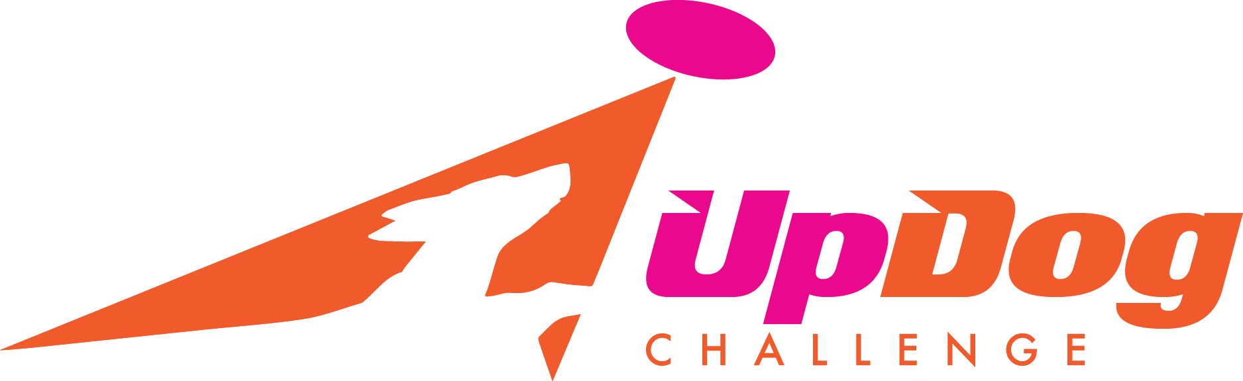
UpDog Challenge – June Bloom
Saturday June 20, 2015
470 Ski Lane, Millersville, MD
Registration 8:30 am Start Time 9:00 am

Games:
- FunKey
- 4Way Play
- Time Warp
- Spaced Out

For Frizgility you need to identify the division you are competing in: Mini, Midi, Maxi:

- Mini Division: Under 13” – Can opt to jump 4”, 8”, 12” or 16”

- Midi Division: 13”-17” – Can opt to jump 8”, 12”, 16” or 20”.

- Maxi Division: Over 17" – Can opt to jump 12”, 16”, 20” or 24"

There are no Mad-Dog Division awards for these games.

For complete rules and information on UpDog please visit their website www.updogchallenge.com

Any entry that is not received via email by the deadline of Thursday, June 18, 2015 will be considered late. All late entries will be charged a $5.00 per team fee, no exceptions. You can pay your entry fees the day of the event, however it is preferred that they are mailed in advance.

- Email pre-registration forms to Laura O’Neill: wickedfrenzy@verizon.net by Thursday, June 18, 2015 to avoid the late fee. If mailing payment, please send by Monday, June 15, 2015 to Laura O’Neill 28 Kelly Drive, Bear, DE 19701 Make checks payable to MADDogs.

- Thank you for adhering to these Rules; it makes a world of difference in organizing Registration Entries ahead of time.

Check# ______ Amount________
Cash Amount________

UpDog Challenge - June Bloom
Hosted by MAD Dogs
June 20, 2015
Registration 8:30 am Start Time 9:00 AM
470 Ski Lane, Millersville, MD

Handler Name:
Address:
City: |  |  |  |  | State: |  |  |  |  | Zip Code:
Phone: |  |  |  |  | Email:
Are you a MAD Dog Member? (Check one) |  |  | Yes |  |  | No | Club Affiliation:

 | Dog Name | Height | Mad Dog Member Fees by # of Games |  |  |  |  | Non Mad-Dog Member Fees by # of Games |  |  |  |  | Late Reg | Total Fee
 | Dog Name | Height | 1 | 2 | 3 | 4 | 5 | 1 | 2 | 3 | 4 | 5
1 |  |  | $8 | $16 | $24 | $26 | $31 | $10 | $20 | $30 | $32 | $37 | $5
2 |  |  | $7 | $14 | $21 | $23 | $28 | $9 | $18 | $27 | $29 | $34 | $5
3 |  |  | $6 | $12 | $18 | $20 | $25 | $8 | $16 | $24 | $26 | $31 | $5
4 |  |  | $5 | $10 | $15 | $17 | $23 | $7 | $14 | $21 | $23 | $28 | $5
Grand Total

# | UpDog Challenge Games | Mark Here if playing this game | UpDog Level | UpDog Division | UpDog Jump Height
1 | FunKey |  | Level 1 Level 2 | Mini Midi Maxi | 4 8 12 16 20 24
1 | 4Way Play |  | Level 1 Level 2
1 | Time Warp |  | Level 1 Level 2
1 | Spaced Out |  | Level 1 Level 2
2 | FunKey |  | Level 1 Level 2 | Mini Midi Maxi | 4 8 12 16 20 24
2 | 4Way Play |  | Level 1 Level 2
2 | Time Warp |  | Level 1 Level 2
2 | Spaced Out |  | Level 1 Level 2
3 | FunKey |  | Level 1 Level 2 | Mini Midi Maxi | 4 8 12 16 20 24
3 | 4Way Play |  | Level 1 Level 2
3 | Time Warp |  | Level 1 Level 2
3 | Spaced Out |  | Level 1 Level 2
4 | FunKey |  | Level 1 Level 2 | Mini Midi Maxi | 4 8 12 16 20 24
4 | 4Way Play |  | Level 1 Level 2
4 | Time Warp |  | Level 1 Level 2
4 | Spaced Out |  | Level 1 Level 2

Release and Waiver of Liability
For and in consideration of my participation in the, Skyhoundz Hyperflite, and Mid Atlantic Disc Dogs event, and for other good and valuable consideration, the receipt and sufficiency of which are hereby acknowledged, I the undersigned, intending to be legally bound do hereby for myself, my heirs, assigns, executors and administrators, waive and release any and all rights and claims for damages or injuries arising out of, or in any way related to, my participation in the Event, which I may have against the following parties: Skyhoundz Hyperflite, and MAD Dogs, the administration and owner of the facility hosting the Event; together with the contractor, agents, employees and representatives of each of them. I certify that my canine and I are healthy and fit to compete in the Event.
I hereby grant to, Skyhoundz Hyperflite, and MAD Dogs the exclusive right to record, broadcast, photograph, film and videotape my performances and related interviews at the Event and to utilize such recordings, broadcasts, photographs, films or videotapes together with my name, image, likeness, voice, and biographical information, for such publicity, promotional or commercial purposes as they may desire. I understand that, Skyhoundz Hyperflite, and MAD Dogs may assign the right to use the recordings, broadcasts, images, photographs, film and videotape of my performance(s) together with my name, image, likeness, voice and biographical information to such person or other entity (including, but not limited to a television broadcaster) as they may desire without my further consent or knowledge and I expressly agree to such assignment.

Signature of |  | Parent or Guardian
Competitor |  | Signature (under 18)
 | Date |  | Date

